
Comsats University Islamabad, Lahore Campus

Midterm Exam <Theory> – SPRING 2024
Course Title | Software Testing | Course Code |  | CSE455 | Credit Hours |  |  | 3(2,1)
Instructor/s | Ms. Sana Rizwan, Ms. Yella Mehroze | Program Name |  | BS Software Engineering
Semester | 8th | Batch | FA20 | Section | A, B, C | Date | April 05, 2024
Time Allowed | 1 hr. 30 minutes | Maximum Marks |  | 30
Student Name |  | Registration No.
Important Instructions/Guidelines:
- All the questions are compulsory
- Be very brief & precise
- Manage your time accordingly
- Return the question paper with the answer sheet

Question #1 [2+3]: [CLO-2]; Bloom Taxonomy Level: <Analyzing>
WhatsApp wants to add functionality to create a community in WhatsApp. Each community can have multiple group chats. People can be added to each group chat individually or the community. As the tester in the team, you have been asked to create a test plan for the new feature before the final release of the project.
- Which of the test strategies will you apply? You need to choose the most appropriate strategies. Give valid reasons.
- Assuming that WhatsApp is already following good software development and delivery practices (Agile + DevOps). And therefore they already have well developed testing practices in place (e.g. Test Case management, bug reporting process, test environments, test data management, etc.). Considering that you need to a quick plan for following user story:
- As a WhatsApp user, I should be able to create a new community by entering a valid and unique community name.
Considering the different parts of a test plan, identify the test plan sections that will be critical to create a small test plan for this individual user story
Question #2 [5]: [CLO-6]; Bloom Taxonomy Level: <Applying>
An e-commerce platform needs to have some loyalty benefits for customers that utilize the platform regularly. They are awarded points on each purchase. The points are awarded in following way:
- If a customer has purchased total of worth Rs 10000- Rs 50000 then the customer gets 1 point per Rs 1000
- If a customer has purchased total of worth Rs 50000- Rs 100000 then the customer gets 5 points per Rs 1000
- If a customer has purchased total of worth Rs 100000 or more then the customer gets 10 points per Rs 1000
- No points are awarded to people who has less than Rs 10000 of total purchase
- If a customer makes a single purchase of more than Rs 5000 then they will get 10 extra points
Perform BVA and negative testing on the given scenario.
Question #3 [5+2]: [CLO-3]; Bloom Taxonomy Level: <Applying>
Perform static testing on the given source code with the reference of adherence to standards and guidelines
- Identify at least 5 issues, highlight the location and provide justification of your selection.
- How Checklist-based method can ensure the avoidance of such deviation.
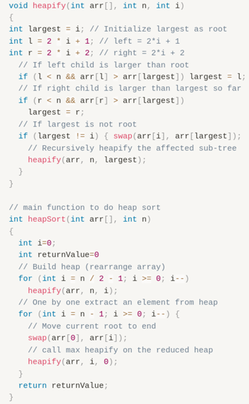
Question #4 [2*5]: [CLO-2, 3]; Bloom Taxonomy Level: <Remembering>
- Top down integration is best suited for sequential or iterative models? Justify your answer.
- Differentiate between verification and validation, stubs and drivers.
- Which type of testing is performed on all the stages of testing levels?
- A software whose features are enhanced/modified in new version, which type of testing is preferred in this case?
- Explain buddy testing and code swapping informal review techniques.
Question #5 [3]: [CLO-1]; Bloom Taxonomy Level: <Understanding>
Most systems are subject to continuous development—for example, to build improved releases of the product. Such releases are usually coordinated with scheduled maintenance work
Testing following such release development follows two main objectives:
- Objective#01: Checking that every new or extended function works as intended
- Objective#02: Checking that pre-existing functionality is not (unintentionally) impaired
How to achieve above both mentioned objectives?

